**AMITY UNIVERSITY RAJASTHAN**

**Date: 01/12/2023**

**“Seasonal and Interannual Variability of Bay of Bengal SST: A Robust Empirical Orthogonal Function Approach”**

*A minor project report submitted in partial fulfillment of curriculum prescribed for the Data Science course for the award of the degree of*

**MASTER OF SCIENCE**

**IN**

**DATA SCIENCE**

*by*

**Sutesna Mondal**

**(A217117722005)**

*Under the Guidance of*

**Dr. Shatrughan Singh**

Assistant Professor, ACOAST

Department of Information Technology

Amity University, Rajasthan

**2022-2024**

**Acknowledgment**

I would express my sincere thanks to everyone who contributed to the successful completion of this brief project, which focused on analysing the relationship between precipitation, relative humidity, specific humidity, and temperature using linear regression analysis.

First and foremost, I extend my heartfelt thanks to my project guide, **Dr. Shatrughan Singh**, for their invaluable guidance, unwavering support, and expert insights throughout the duration of this project. Their mentorship played a pivotal role in shaping the direction and methodology of the research.

I am also thankful to **Amity University Rajasthan** for providing the necessary resources, infrastructure, and academic environment that facilitated the smooth execution of this project.

I extend my appreciation to my fellow classmates and friends who actively participated in discussions, shared ideas, and provided constructive feedback, enhancing the quality of this research endeavour.

Last but not least, I am thankful to my family for their constant encouragement, understanding, and support throughout this academic pursuit.

This project has been a tremendous learning experience, and each of these contributions has played a vital role in its successful completion.

Thank you all.

**Sutesna Mondal**

**M.Sc. in Data Science**

**A217117722005**

**Date:01/12/2023**

**Declaration**

I, **Sutesna Mondal** , hereby declare that the minor project titled " **Seasonal and Interannual Variability of Bay of Bengal SST: A Robust Empirical Orthogonal Function Approach** " is the result of my original research work. All the information, data, and findings presented in this project are authentic and have not been submitted elsewhere for any academic purpose.

This project is submitted in partial fulfilment of the requirements for **M.Sc. Data Science- III**, and I take full responsibility for its content.

**Sutesna Mondal**

**M.Sc. in Data Science**

**A217117722005**

**Date: 01/12/2023**

**Certificate of Completion**

This is to certify that **Sutesna Mondal** has successfully completed the minor project titled**" Seasonal and Interannual Variability of Bay of Bengal SST: A Robust Empirical Orthogonal Function Approach** **"**under my supervision from 27th Oct, 2023 to 29th Nov, 2023 as part of the requirements for the **M.Sc. Data Science– III**at **AIIT, Amity University Rajasthan**.

This project, showcasing analytical skills and dedication to scientific inquiry, is hereby recognized for its originality and successful execution.

**Date: 01/12/2023**

**Dr. Shatrughan Singh**

**ACOAST Associate Faculty**

**Sign:**

**Certificate of Project Approval**

This is to certify that the minor project titled **" Seasonal and Interannual Variability of Bay of Bengal SST: A Robust Empirical Orthogonal Function Approach** **"** conducted by **Sutesna Mondal** under the guidance of **Dr. Shatrughan Singh** has been reviewed and approved by the Department of **AIIT**at **Amity University Rajasthan.**

The project has met the academic standards and requirements set forth by the department, and its successful completion contributes to the knowledge and understanding in the field.

**Date: 01/12/2023**

**Dr. Swapnesh Taterh**

**Head of Institution**

**AIIT, AUR**

**Sign:**

**Seasonal and Interannual Variability of Bay of Bengal SST: A Robust Empirical Orthogonal Function Approach**

Sutesna Mondal

sutesnamondal@gmail.com

In this study, the Singular Value Decomposition (SVD) method was used to perform an Empirical Orthogonal Function (EOF) analysis on long-term monthly Sea Surface Temperature (SST) data over the Bay of Bengal (BOB). Using an objective analysis technique, monthly temperature data was obtained from the integration of recent ARGO observations into the Levitus Climate. This study's objective is split into two parts: reconstructing all of the data from the dominant modes and obtaining intrinsically valuable information through EOF. Skill analysis was used to calculate computational accuracy. When the original and rebuilt datasets were compared, it became clear that the EFF analysis was able to extract the small intrinsic signals while also acting as a smoothing technique to remove the unwanted signals.

*Keywords: EOF, SVD, SST, Temporal mode, Spatial mode*

**Introduction**

The study of potential spatial patterns of climate variability and their temporal evolution typically involves the application of empirical orthogonal function (EOF) analyses.The original climate data is also projected on an orthogonal basis in EOF analysis. However, the eigenvectors of a spatially weighted anomaly covariance matrix are computed to obtain this orthogonal basis, and the corresponding eigenvalues give an indication of the percentage of variance explained by each pattern. Consequently, mutually orthogonal space patterns where the data variance is concentrated can be represented by EOFs of a space-time physical process, where the largest portion of the variance is attributed to the first pattern, the largest portion of the remaining variance to the second, and so on.

The Bay of Bengal (BOB) is a significant geographical feature because of its distinct internal dynamics and physics. Oceanographers have continued to focus their research efforts on BOB over the years. But for a long time, it has been challenging to interpret ocean processes due to a lack of appropriate in-situ data. The issue has largely been resolved since the release of the ARGO float data. Scholars are utilizing novel computational methodologies to produce datasets that accurately depict the dynamics of the ocean1-2.

It is standard procedure to apply various statistical techniques when interpreting long-term time series datasets, such as SST data. These techniques are able to extract the inherent qualities and features, which might change depending on the time and space scale.

Statistical techniques like the Empirical Orthogonal Function (EOF), which are frequently employed in the study of oceanography and climate change, can be used to complete the task.

The EOF method has been used extensively in the research of the Indian Ocean3. It hasn't been utilized very often in the BOB case, though. Therefore, this study aims to apply the EOF method to the SST dataset of the BOB for objective analysis. The remaining objective of this work is to assess the method's effectiveness for identifying the temporal and spatial characteristics of the BOB region.

**Data Resources**

Gather the data from International Research Institute for Climate and Society(IRI) website. [Data link](http://iridl.ldeo.columbia.edu/SOURCES/.NOAA/.NCEP/.EMC/.CMB/.GLOBAL/.Reyn_SmithOIv2/.monthly/ssta/data.nc) , containing information on time, longitude, latitude, Sea surface temperature. Bay of Bengal,part of Indian Ocean has been selected on this study to EOF analysis. The selected latitude is 5 N to 25 N and longitude is 80 E to 100 E.

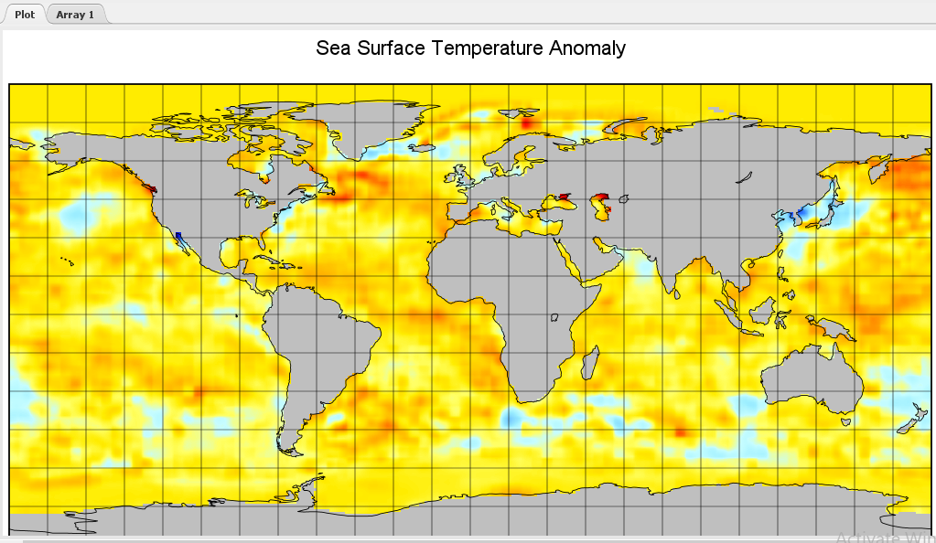

**Fig 1: Sea Surface Temperature Anomaly**

**Methodology**

Multivariate datasets are broken down into a few orthogonal functions or modes using EOF analysis. The original dataset's variability in both temporal and spatial patterns is reflected in these modes. In the fields of oceanography and meteorology where long time series data are available, the EOF technique is widely used. Three-dimensional data must be converted into two-dimensional (spatial × temporal) data in order to perform the EOF analysis.

**Install Libraries and Load the NetCDF Datase**

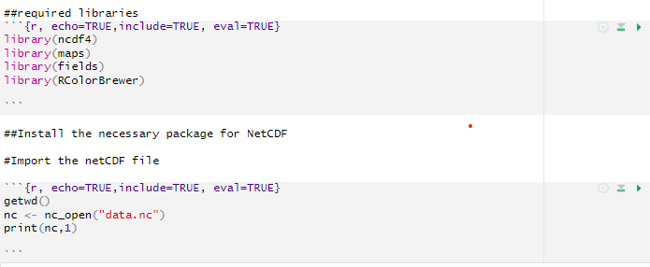

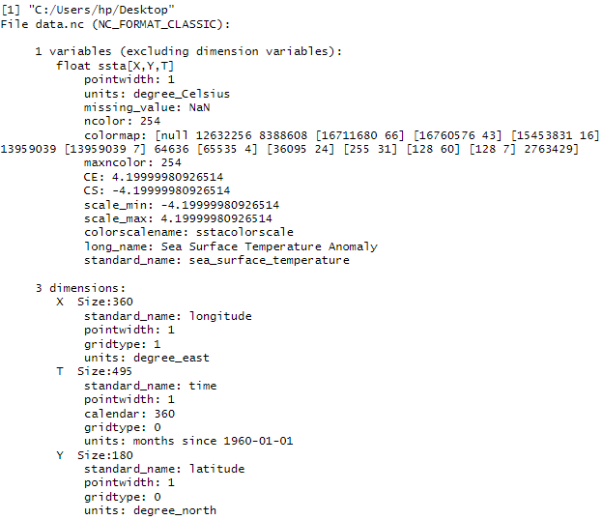

**Set the latitude and longitude of Bay of Bengal and extract the sea surface temperature anomalies**

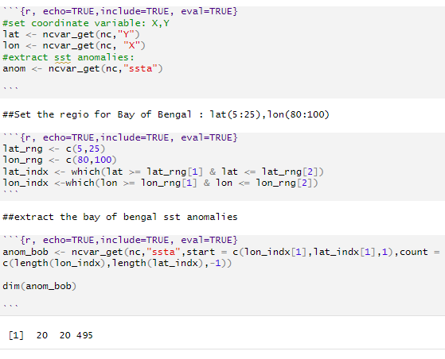

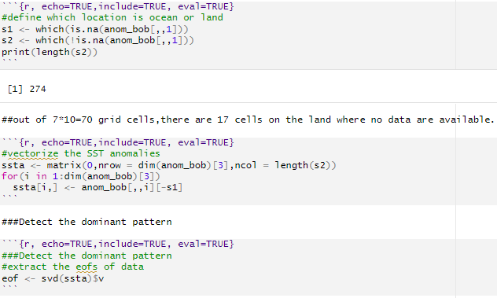

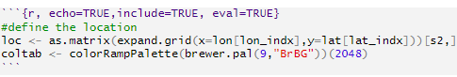

**Plot 1st EOF**

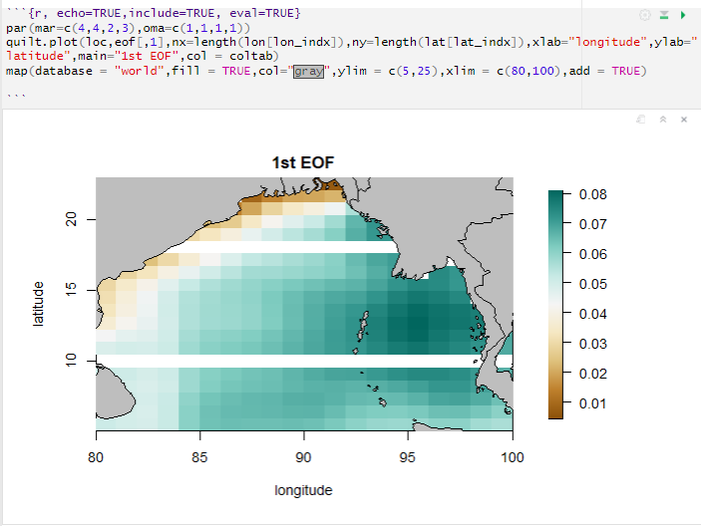

**Plot 2nd EOF**

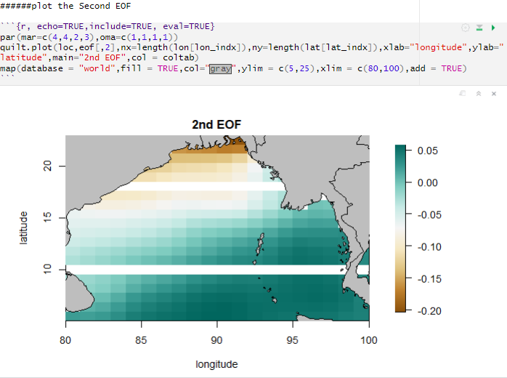

**Conclusion**

The discussion above leads to the conclusion that EOF operation can identify prevailing temporal and spatial features, such as the periodic cooler SST tongue formation, near Sri Lanka and the southern part of the bay, with ease. It can also perform well for the Bay of Bengal region. A clear picture is provided by the first few dominant modes with higher variances. Mode 2 of the temporal EOF and Mode 1 of the spatial EOF exhibit a strong summer signal, whereas Mode 2 of the temporal EOF in the spatial pattern corresponds to a winter pattern. In spatial EOF, the summer signal is weak.

The two seasonal signal is displayed in mode. But as we move forward toward the other modes; features become challenging identification as a result of unusual spatial behavior trends. Furthermore, it's acknowledged that the interpretations of The EOF findings may be complex and necessitate appropriate understanding of basin dynamics.

**References**

Reynolds, R.W., N.A. Rayner, T.M. Smith, D.C. Stokes, and W. Wang, 2002: An Improved In Situ and Satellite SST Analysis for Climate. J. Climate, 15, 1609-1625

Jana S, Sil S, Chakraborty A, Ravichandran M, Development of High Resolution Climatology for the Bay of Bengal using ARGO Observations, Adv. GeoSci., 24 (2011) 105-116.

Jana S, Sil S, Chakraborty A, Objective Analysis of Temperature over the Bay of Bengal using Levitus and ARGO datasets, Proc. Nat. Conf. Coastal Processes, CESS, Trivandrum, (2010) 140-143.

Cherchi A, Gualdi S, Behera S, Luo J J, Masson S, Yamagata T, Navarra A, The Influence of Tropical Indian Ocean SST on the Indian Summer Monsoon, Journal of Climate, 20 (2007) 3083-3105.

Boyer T, Levitus S, Garcia H, Locarnini R A, Stephens C, Antonov J, Objective analyses of annual, seasonal, and monthly temperature and salinity for the world ocean on a 0.25 degree grid, Int. J. Clim., 25(2005) 931-945.